Admin Use Case Diagrams and Table:
- Manage Templates:
Use Case Diagram:
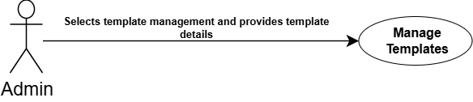

Use Case ID
Use Case Name | Manage Templates
Description | Allows admin to create, update, delete, and organize dynamic message templates using placeholder fields for campaigns.
Primary Actor | Admin
Pre-Condition | The user must be successfully logged into the dashboard with appropriate role privileges.
Post-Condition | The template is created, updated, or removed from the system database and made available for campaigns.
Basic Flow | Actor Action | System Action
 | - Navigates to the Template Management module.  - Chooses to create a new template or edit an existing one.  - Inputs template subject, body content, and dynamic placeholders (e.g., student name, department, course).  - Submits the template details. | - Validates the template syntax and placeholder fields.  - Saves the template record in the database.  - Displays a success message to the user.
Alternate Flow | • If required placeholder fields are missing, the system displays a validation error message.  • If an unauthorized user attempts access, the system restricts access and logs the event.
Use Case Description:
- Attach Template:
Use Case Diagram:

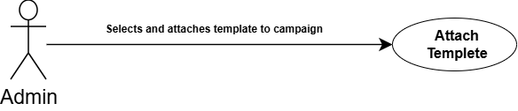

Use Case Description:
Use Case ID
Use Case Name | Attach Templates
Description | Allows admin and faculty members to select and link pre-created dynamic templates to specific communication campaigns.
Primary Actor | Admin.
Pre-Condition | Templates must already be created, and a campaign draft must be active.
Post-Condition | The selected template is successfully linked to the campaign for automated message formatting.
Basic Flow | Actor Action | System Action
 | - Opens the campaign management module.  - Select an existing campaign or create a new one.  - Click on the “Attach Template” option.  - Selects the desired template from the list and confirms. | - Retrieves the selected template content and placeholder schema.  - Links the template ID to the campaign record in the database.  - Previews the template formatting with sample data.
Alternate Flow | - If no templates exist, the system prompts the user to create a new template first.

- Manage C-Records:
Use Case Diagram:
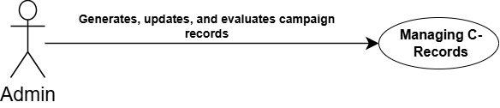

Use Case Description:
Use Case ID
Use Case Name | Manage C-Records
Description | Manages campaign-derived communication records (C-Records) that are utilized by the Automation Rule Engine (ARE) for rule evaluation and event-driven messaging.
Primary Actor | Admin
Pre-Condition | Campaigns must be initialized, and academic trigger events (e.g., attendance shortage) must be configured.
Post-Condition | C-Records are updated, logged, and evaluated by the ARE to execute automated workflows.
Basic Flow | Actor Action | System Action
 | - Accesses campaign execution or automation rule logs.  - Views or updates C-Record parameters derived from campaign executions. | - Generate C-Records dynamically from active campaigns and academic data.  - Passes C-Record to the Automation Rule Engine (ARE) for system evaluation.  - Triggers automated actions (e.g., warning notifications) based on evaluation results.
Alternate Flow | - If evaluation criteria fail or data is missing, ARE flags the record for manual review.

- Monitoring Performance:
Use Case Diagram:
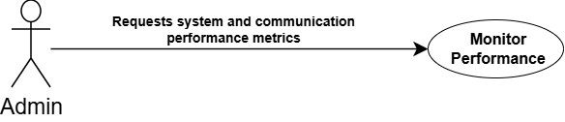

Use Case Description:
Use Case ID
Use Case Name | Monitor Performance
Description | Allows users to view high-level performance metrics, system response times, and communication throughput on their dashboards.
Primary Actor | Admin
Pre-Condition | User must be logged into their role-specific dashboard.
Post-Condition | Performance metrics and analytical charts are rendered successfully on the user interface.
Basic Flow | Actor Action | System Action
 | - Navigates to the Dashboard performance section.  - Selects date range or specific metric filter e.g. Department, Semester, Course etc. | - Queries system logs and database metrics.  - Computes overall performance indicators (response times, processing load).  - Renders visual analytics dashboards.
Alternate Flow | - If server connection lags or data fails to load, a fallback error message and retry option are displayed.

- View Delivery Analytics:
Use Case Diagram:
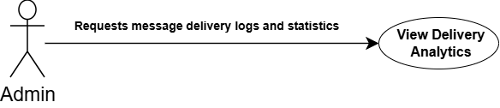

Use Case Description:
Use Case ID
Use Case Name | View Delivery Analytics
Description | Enables users to track message delivery status, bounce rates, success rates, and delivery logs across channels.
Primary Actor | Admin
Pre-Condition | Messages or campaigns must have been dispatched previously.
Post-Condition | Detailed delivery analytics reports are presented to the user.
Basic Flow | Actor Action | System Action
 | - Navigates to Analytics and Reporting -> Delivery Reports.  - Selects a specific campaign or time period. | - Fetches delivery receipts and logs from the messaging infrastructure.  - Calculates delivery success and status seen message vs. bounce percentages.  - Displays graphical charts and status tables.
Alternate Flow | - If no delivery records exist for the selected filter, the system displays an empty state notification.

- View Institutional Totals:
Use Case Diagram:
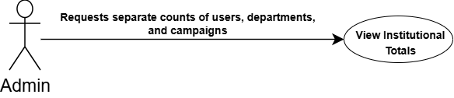

Use Case Description:
Use Case ID
Use Case Name | View Institutional Totals
Description | Allows the administrator to view segregated analytical counts of total active users (students and faculty separately), academic departments, and total campaigns.
Primary Actor | Admin
Pre-Condition | Administrator must be logged into the admin dashboard portal.
Post-Condition | Administrator must be logged into the admin dashboard portal.
Basic Flow | Actor Action | System Action
 | - Opens Dashboard overview section. | - Queries the user database for total registered faculty and students.  - Queries academic records for total active departments.  - Queries campaign modules for total active campaigns.  - Displays categorized metric cards on the UI.
Alternate Flow | - If database queries timeout, cached metric summaries are displayed with a sync warning.

- Delivery & Response Rate:
Use Case Diagram:
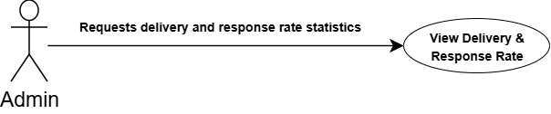

Use Case Description:
Use Case ID
Use Case Name | Delivery & Response Rate
Description | Calculates and displays message delivery success percentages and average response rates from recipients.
Primary Actor | Admin
Pre-Condition | Interaction and messaging data must be available in the system logs.
Post-Condition | Delivery and response rate metrics are rendered on the reporting module.
Basic Flow | Actor Action | System Action
 | - Accesses the Analytics module as well as statistics boxes in dashboard overview section.  - Chooses “Delivery and Response Rate” report view. | - Aggregates sent versus delivered message counts.  - Computes faculty-to-student query response times and response percentages.  - Renders comparative rate graphs.
Alternate Flow | - If response data is incomplete, partial statistics are displayed with a data notice.

- Message Count:
Use Case Diagram:
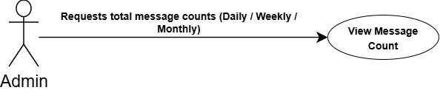

Use Case Description:
Use Case ID
Use Case Name | Message Count
Description | Displays aggregated message counts categorized by daily, weekly, and monthly intervals for administrative tracking.
Primary Actor | Admin
Pre-Condition | System must have stored message logs with timestamps.
Post-Condition | Total message counts for selected time filters are displayed.
Basic Flow | Actor Action | System Action
 | - Navigates to messaging statistics or its on dashboard overview section.  - Selects time filter (Daily, Weekly, or Monthly). | - Filters message log entries according to the selected timeframe.  - Aggregates total message volume.  - Displays the numerical count and trend indicator.
Alternate Flow | - If the selected date range contains no logs, a zero count is displayed.

- Engagement Graph:
Use Case Diagram:
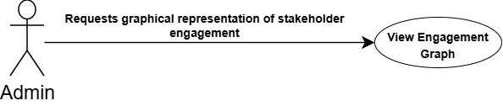

Use Case Description:
Use Case ID
Use Case Name | Engagement Graph
Description | Renders visual charts (graphs) showing recipient interaction levels, open rates, and engagement trends over time.
Primary Actor | Admin
Pre-Condition | Campaign tracking and interaction data must be recorded.
Post-Condition | Interactive engagement graphs are rendered on the analytics interface.
Basic Flow | Actor Action | System Action
 | - It`s shown on the Dashboard Overview section. Admin can also access the Analytics and Reporting tab.  - See for the “Engagement Graph” visualization box or tab in analytics and reporting tab. | - Processes historical engagement and open-rate logs.  - Generates chart datasets using charting libraries (e.g., Chart.js / Recharts).  - Displays the responsive engagement graph to the user.
Alternate Flow | - If graph rendering fails due to script errors, a tabular fallback data view is provided.

